

**North South University**

Department of Electrical and Computer Engineering

**Lab Project Report**

Semester : NSU Fall 2022

Course Code : CSE 115L

Section : 12

Group Name : B2

Faculty : Rifat Ahmed Hassan (RIH)

Lab Instructor : A. S. M. Sabiqul Hassan

Project Topic : Bus Management System

GitHub Repo Link: https://github.com/Mahadi9664/CSE115L_Project

Submission Date: 28/12/2022

|  |  |
| --- | --- |
| Student Information | GitHub Account Links |
| NSU ID: 2231265042  NSU NAME: Moniruzzaman Mahadi  NSU EMAIL:  moniruzzaman.mahadi@northsouth.edu | https://github.com/Mahadi9664 |
| NSU ID: 2232058642  NSU NAME: Sadman Sakib  NSU EMAIL: sadman.sakib26@northsouth.edu | https://github.com/SadmanSkb55 |
| NSU ID: 2233264642  NSU NAME: Siam Sheikh  NSU EMAIL: siam.sheikh@northsouth.edu | https://github.com/siam1444 |

## BUS MANAGEMENT SYSTEM

Our system will contain:

* Login functionality.
* Option for ticket master to sell ticket to passengers.
* Ticket invoice print
* Option for manager to check bus data such as profit, revenue etc.
* Option of searching for passenger information(only for manager).

Our bus management system will include a welcome page which will give you two options to log in. You can either log in as the manager or as one of the ticket masters. The ticket masters will have their assigned buses and they will sell tickets to passengers for the bus. The data will be saved. This data can later be accessed and searched by the manager. You can create account for ticketmaster as the manager. If you login as the manager. You will be able to do three things: Revenue calculation, search information, see all invoice.

Below on the next page is a flowchart demonstrating our project.

The flowchart

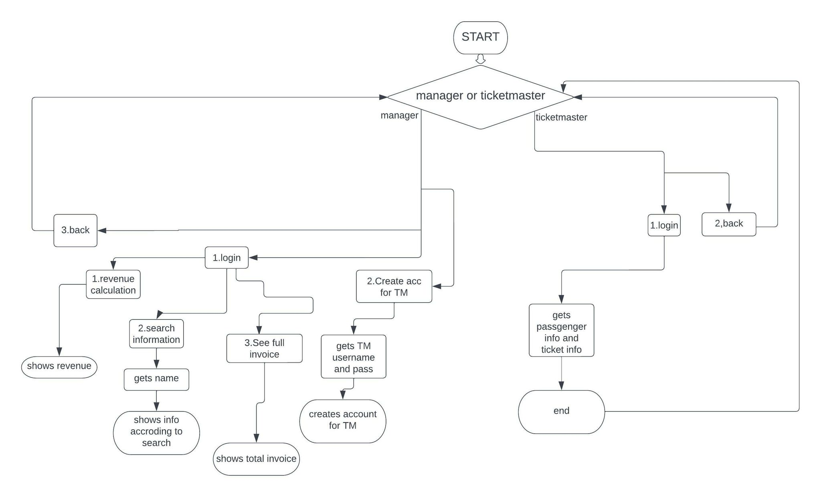

The opening page will welcome the user.

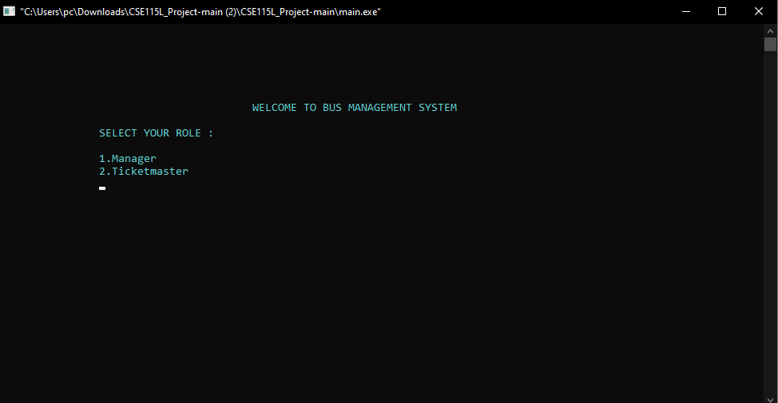

It will give two options:

1. Manager
2. Ticketmaster

Choosing 1 will take you to this page:

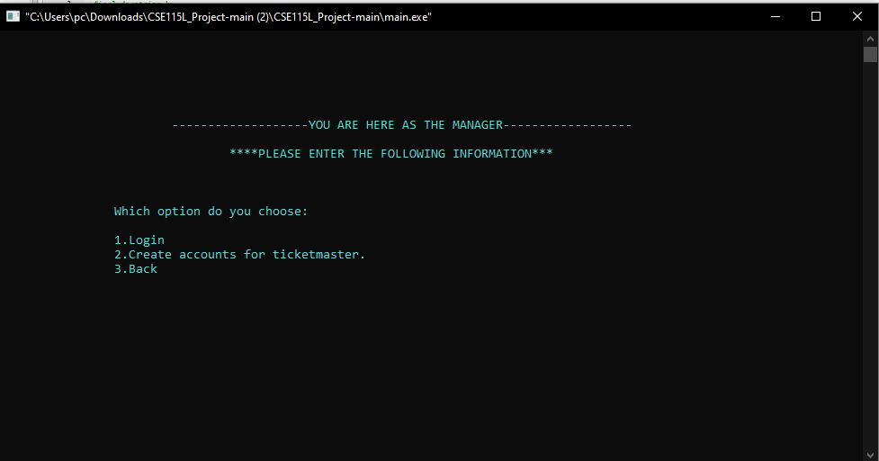

If you choose to login it will ask you for username and password.

It will only allow you to login if the username and password matches.

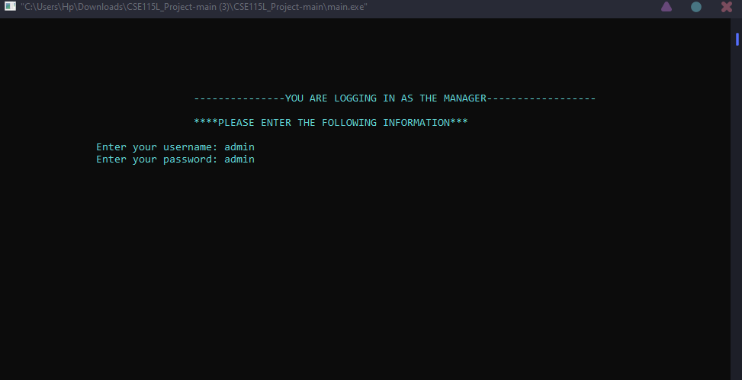

If successfully logged in, it will show this page.

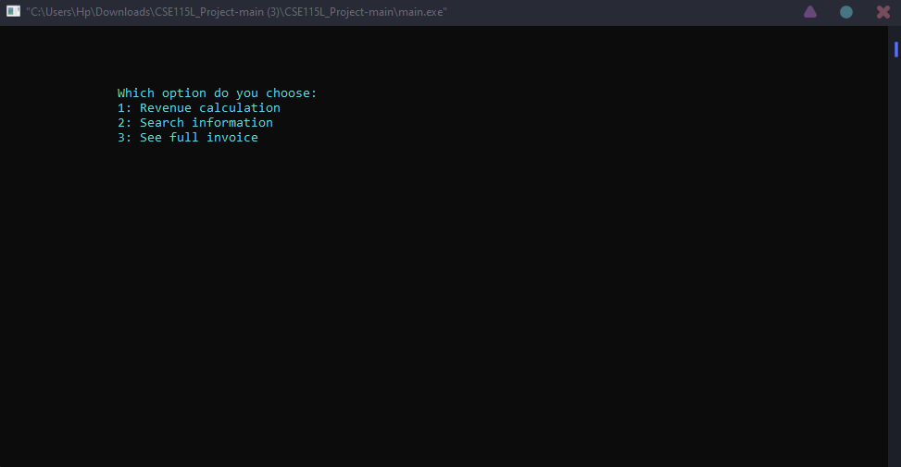

The revenue search will show the revenue of all the buses for the day

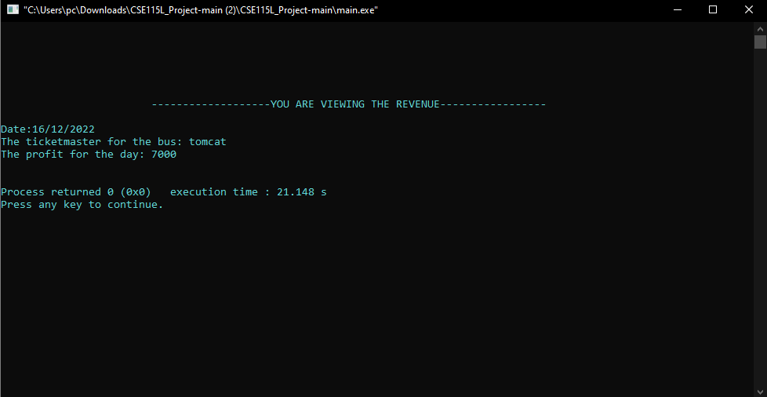

Search information will allow the manager to search for information of ticket buyers.

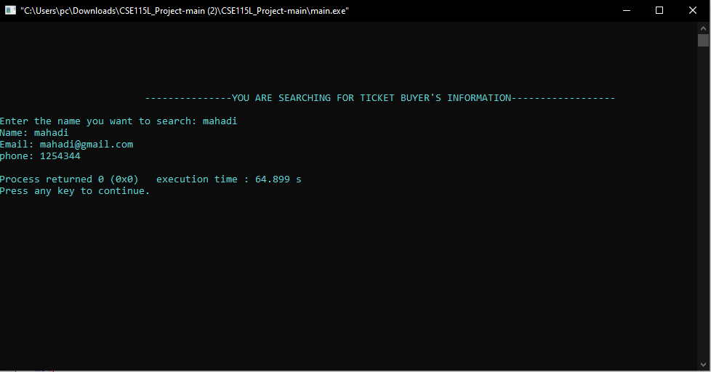

And invoice print will allow manager to see all the invoice for the day.

On the other hand, on the manager tab, you can create accounts for ticket-master.

It will allow to create new username and password for managers.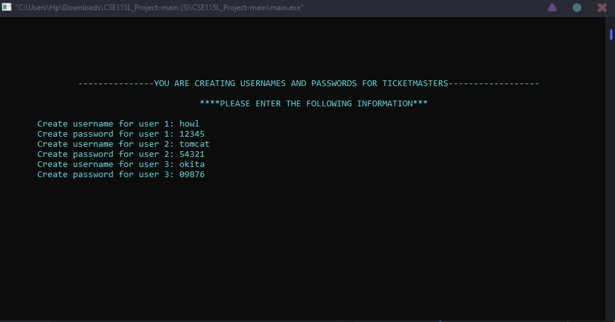

On the other hand, if you choose to login as ticketmaster

It will first show you this page.

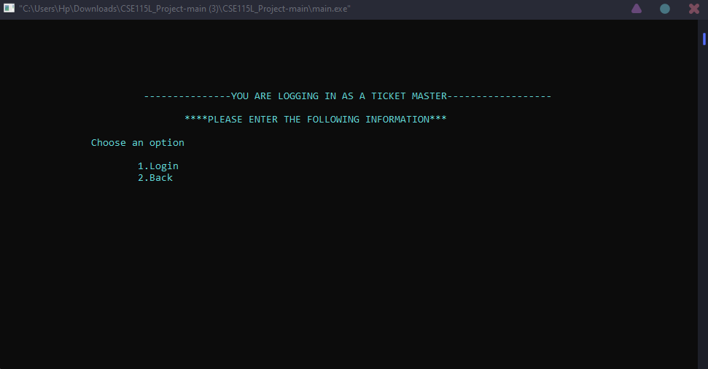

Pressing 1 will allow you to enter username and password.

If username and password match any of the ones created by manager, it will allow to login.

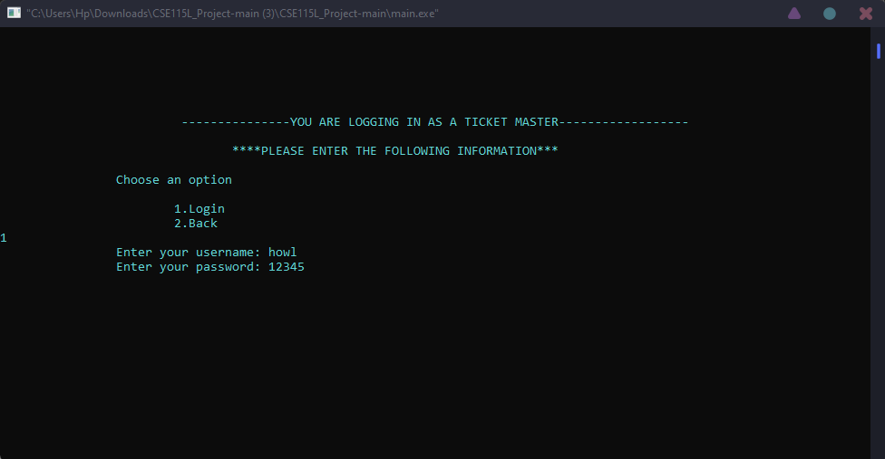

First it will ask for the following info

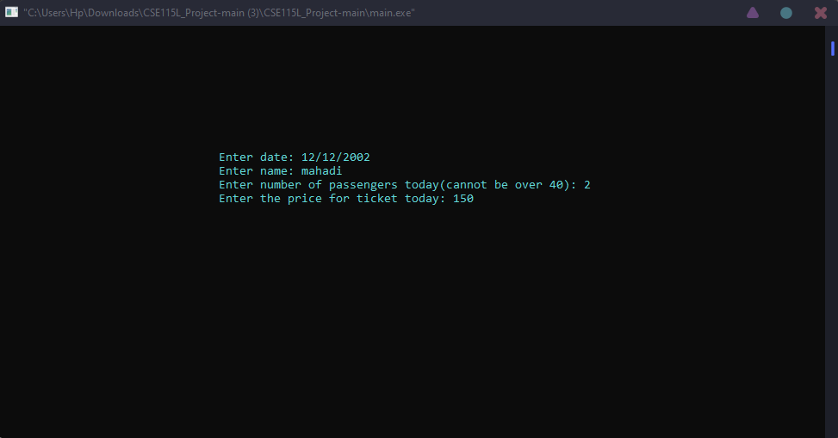

Then it will ask for information of each passenger

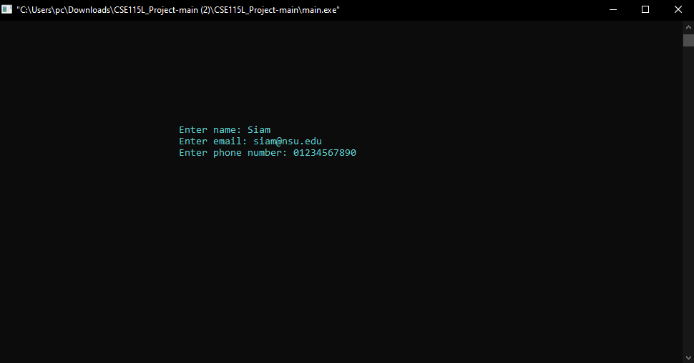

And finally it will go back to the login page when done.

**FULL CODE**

#include <stdio.h>

#include <stdlib.h>

#include<string.h>

#include<windows.h>

struct manager

{

char username[20];

char password[20];

};

struct ticketmaster

{

char username[20];

char password[20];

};

struct invoice

{

char name[20];

char email[40];

char phone[20];

};

typedef struct invoice inv;

int rolechk(int x)

{

printf("\t\t");

scanf("%d",&x);

printf("\e[1;1H\e[2J");

printf("\n\n\n\n\n\n\t");

if(x==1)

{

printf("\t\t-------------------YOU ARE HERE AS THE MANAGER------------------ \n\n\t\t\t\t****PLEASE ENTER THE FOLLOWING INFORMATION***\n\n");

return 1;

}

else if(x==2)

{

printf("\t\t ---------------YOU ARE LOGGING IN AS A TICKET MASTER------------------ \n\n\t\t\t\t****PLEASE ENTER THE FOLLOWING INFORMATION***\n\n");

return 2;

}

}

int mngrOptions(void)

{

int x;

printf("\t\t");

scanf("%d",&x);

printf("\e[1;1H\e[2J");

printf("\n\n\n\n\n\n\t");

if(x==1)

{

printf("\t\t-------------------YOU ARE VIEWING THE REVENUE----------------- \n\n");

return 1;

}

else if(x==2)

{

printf("\t\t ---------------YOU ARE SEARCHING FOR TICKET BUYER'S INFORMATION------------------ \n\n");

return 2;

}

}

void welcome()

{

int i;

char x=219;

char c[50]="WELCOME TO BUS MANAGEMENT SYSTEM";

printf("\n\n\n\n\n\n\t\t\t\t\t");

for(i=0; i<=50; i++)

{

printf("%c",c[i]);

Sleep(50);

}

}

int logincheck(int x)

{

printf("\t\t");

scanf("%d",&x);

printf("\e[1;1H\e[2J");

printf("\n\n\n\n\n\n\t");

if(x==1)

{

printf("\t\t\t---------------YOU ARE LOGGING IN AS THE MANAGER------------------ \n\n\t\t\t\t****PLEASE ENTER THE FOLLOWING INFORMATION***\n\n");

return 1;

}

else if(x==2)

{

printf("\t---------------YOU ARE CREATING USERNAMES AND PASSWORDS FOR TICKETMASTERS------------------\n\n\t\t\t\t\t****PLEASE ENTER THE FOLLOWING INFORMATION***\n\n");

return 2;

}

}

void loadingBar()

{

int i=1;

char x=219;

printf("\n\n\n\n\n\n");

printf("\t\t\t\t\t\t");

printf("Please wait...........\n\t\t\t\t\t\t");

for(i=0; i<=20; i++)

{

printf("%c",x);

Sleep(70);

}

system("cls");

}

int main()

{

system("color 0b");

struct manager m;

struct ticketmaster tm[5];

int role;

int option;

loadingBar();

welcome();

//asking user to enter role and taking input

char content[1000];

char slct[]="\n\n\t\tSELECT YOUR ROLE :\n\n\t\t1.Manager\n\t\t2.Ticketmaster\n\t\t\n";

int i;

menu:

for(i=0; i<=52; i++)

{

printf("%c",slct[i]);

Sleep(40);

}

//printf("\n\n\t\tSELECT YOUR ROLE :\n\n\t\t1.Manager\n\t\t2.Ticketmaster\n\t\t");

int r=rolechk(role);

if(r==1) //MANAGER

{

char slct1[500]="\n\n\t\tWhich option do you choose: \n\n\t\t1.Login\n\t\t2.Create accounts for ticketmaster.\n\t\t3.Back\n\t\t\n";

for(int i=0; i<=strlen(slct1); i++)

{

printf("%c",slct1[i]);

Sleep(40);

}

int r=logincheck(option);

if(r==1) //MANAGER LOGIN

{

mngr:

printf("\t\tEnter your username: ");

fflush(stdin);

gets(m.username);

printf("\t\tEnter your password: ");

fflush(stdin);

gets(m.password);

char str[]="admin";

if(strcmp(m.username,str)==0 && strcmp(m.password,str)==0)

{

system("cls");

printf("\n\n\n\n\t\tWhich option do you choose: \n");

printf("\t\t1: Revenue calculation\n");

printf("\t\t2: Search information\n");

printf("\t\t3: See full invoice\n");

int r = mngrOptions();

if(r==1)

{

FILE *fp;

fp=fopen("revenue.txt","r");

char c;

while((c=getc(fp))!=EOF)

{

putchar(c);

}

fclose(fp);

}

else if(r==2)

{

char searchName[20];

char word[50];

char ch;

int counter =0;

int pos[10];

int pointer =0;

int loop;

char filename[]="invoice.txt";

printf("Enter the name you want to search: ");

scanf("%s",searchName);

FILE* fptr;

fptr = fopen("invoice.txt", "r");

/*if(fptr!=NULL)

{

printf("file can not open.");

}*/

char search[50];

strcpy(search,searchName);

printf("Name: ");

do

{

ch = fscanf(fptr, "%s", word);

if(strcmp(word, search) == 0)

{

pos[counter] = pointer;

counter++;

puts(word);

break;

}

pointer++;

}

while (ch != EOF);

int count = 0;

if ( fptr != NULL )

{

char line[256]; /* or other suitable maximum line size */

while (fgets(line, sizeof line, fptr) != NULL) /* read a line */

{

if (count == counter)

{

//use line or in a function return it

// //in case of a return first close the file with "fclose(file);"

printf("%s", line);

fclose(fptr);

}

else

{

count++;

}

}

}

fptr = fopen("invoice.txt", "r");

/*if(fptr!=NULL)

{

printf("file can not open.");

}*/

char search1[50];

strcpy(search1,searchName);

do

{

ch = fscanf(fptr, "%s", word);

if(strcmp(word, search1) == 0)

{

pos[counter] = pointer;

counter++;

break;

}

pointer++;

}

while (ch != EOF);

int count1 = 0;

if ( fptr != NULL )

{

char line[256]; /* or other suitable maximum line size */

while (fgets(line, sizeof line, fptr) != NULL) /* read a line */

{

if (count1 == counter)

{

//use line or in a function return it

// //in case of a return first close the file with "fclose(file);"

printf("p");

printf("%s", line+1);

fclose(fptr);

}

else

{

count1++;

}

}

}

fclose(fptr);

if(counter==0)

{

printf("Error. The name you are searching for couldn't be found.");

}

}

else if(r==3)

{

FILE *fp;

fp=fopen("invoice.txt","r");

char c;

while((c=getc(fp))!=EOF){

putchar(c);

}

fclose(fp);

}

//goto menu;

}

else

{

printf("\e[1;1H\e[2J");

printf("\t\n\n\n\n\n\n\n\n\n");

printf("\t\tPlease enter the correct information and try again\n\n");

Beep(800,1000);

goto mngr; // beeps and goes to manager input if password is incorrect

}

}

else if(r==2) //Create accounts

{

for(int i=0; i<3; i++)

{

printf("\tCreate username for user %d: ",i+1);

fflush(stdin);

gets(tm[i].username);

printf("\tCreate password for user %d: ",i+1);

fflush(stdin);

gets(tm[i].password);

FILE* fptr;

fptr = fopen("passwords.txt", "a");

fprintf(fptr, "%s",tm[i].username);

fprintf(fptr, "%s\n",tm[i].password);

fclose(fptr);

}

system("cls");

printf("\n\n\tOperation completed sucsessfully");

//goto menu;

}

else if(r==3)

{

goto menu;

}

}

else if(r==2) //ticket master login

{

int r;

printf("\t\tChoose an option\n\n\t\t\t1.Login\n\t\t\t2.Back\n");

scanf("%d",&r);

if(r==1)

{

struct manager n;

char word[50];

char ch;

int count =0;

int pos[10];

int pointer =0;

int loop;

char filename[]="passwords.txt";

tmpass:

printf("\t\tEnter your username: ");

fflush(stdin);

gets(n.username);

printf("\t\tEnter your password: ");

fflush(stdin);

gets(n.password);

FILE* fptr;

fptr = fopen("passwords.txt", "r");

/*if(fptr!=NULL)

{

printf("file can not open.");

}*/

char search[50];

strcpy(search,strcat(n.username,n.password));

do

{

ch = fscanf(fptr, "%s", word);

if(strcmp(word, search) == 0)

{

pos[count] = pointer;

count++;

}

pointer++;

//printf("%s",word);

}

while (ch != EOF);

if(count == 0)

{

printf("\e[1;1H\e[2J");

printf("\t\n\n\n\n\n\n\n\n\n");

printf("\t\tPlease enter the correct information and try again\n\n");

Beep(800,1000);

goto tmpass; //beeps and goes to tm login page again

}

else

{

char date[30];

char name[20];

int passenger_num;

int ticket_price;

inv passengers[40];

printf("\e[1;1H\e[2J");

printf("\t\n\n\n\n\n\n\n\n\n\t\t\t\t");

printf("Enter date: ");

fflush(stdin);

gets(date);

printf("\t\t\t\t");

printf("Enter name: ");

fflush(stdin);

gets(name);

printf("\t\t\t\t");

printf("Enter number of passengers today(cannot be over 40): ");

scanf("%d",&passenger_num);

printf("\t\t\t\t");

printf("Enter the price for ticket today: ");

scanf("%d",&ticket_price);

int revenue=ticket_price*passenger_num;

FILE* fptr;

fptr = fopen("revenue.txt", "a");

char strRev[10];

sprintf(strRev, "%d", revenue);

// Now str contains the integer as characters

// print our string

fputs("Date: ",fptr);

fprintf(fptr, "%s\n",date);

fputs("The ticketmaster for the bus: ", fptr);

fprintf(fptr, "%s\n",name);

fputs("The profit for the day: ", fptr);

fprintf(fptr, "%s\n",strRev);

fclose(fptr);

for(int i=0; i<passenger_num; i++) //taking the input for invoice

{

printf("\e[1;1H\e[2J");

printf("\t\n\n\n\n\n\n\n\n\n\t\t\t\t");

printf("Enter name: ");

fflush(stdin);

gets(passengers[i].name);

printf("\t\t\t\t");

printf("Enter email: ");

fflush(stdin);

gets(passengers[i].email);

printf("\t\t\t\t");

printf("Enter phone number: ");

fflush(stdin);

gets(passengers[i].phone);

FILE* fptr;

fptr = fopen("invoice.txt", "a");

fputs("Name: ",fptr);

fprintf(fptr, "%s\n",passengers[i].name);

fputs("Email: ",fptr);

fprintf(fptr, "%s\n",passengers[i].email);

fputs("Phone: ",fptr);

fprintf(fptr, "%s\n",passengers[i].phone);

fclose(fptr);

}

}

system("cls");

printf("\n\n\t\t\t\t\tInformation saved successfully");

goto menu;

}

else if(r==2)

{

system("cls");

goto menu;

}

}

}